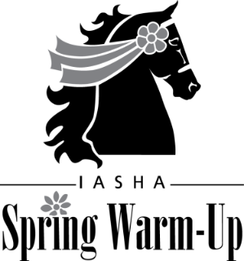
March 17-19, 2023

Spring Warm-Up VENDOR AGREEMENT
Vendor Name______________________________________________________________
Address___________________________________________________________________
City___________________________________State________Zip____________________
Phone____________________Cell____________________Fax______________________
Contact Person____________________________Email____________________________
Arrival/move in day_________________________________________________________
Description of products or services offered at show _____________________________
__________________________________________________________________________
__________________________________________________________________________
Name of liability insurer_____________________________________________________

This agreement is entered into by and between the Vendor and the Indiana American Saddlebred Horse
Association and UPHA Chapter 11 Academy Club (the Show), managers of the Spring Warm-Up Show.
In consideration for the payment of a nonrefundable fee in the amount of $125, Vendor will be allowed to
exhibit its wares, products, and/or services at the Spring Warm-Up Show to be held March 17-19, 2023, at C
Bar C Expo, Cloverdale IN, pursuant to the Vendor Rules and Layout Plan established by the show. Vendor
agrees, as a condition of its participation, to follow Vendor Rules and acknowledges that a violation of those
rules may be grounds for expulsion from the Spring Warm-Up Show without recourse or refund of the fee.
Vendor agrees to hold harmless, defend and indemnify the Show and the C Bar C Expo, their agents,
employees, volunteers, officials and assigns from any and all claims, suits, causes of action, judgments and
executions which may result from the performance of this agreement or the action or inaction of the Vendor.
Further, all parties agree the courts of Indiana are the proper forum for any and all actions which may arise
under this agreement. Vendor also agrees to follow all state and local health protocols, which may include wearing a mask and social distancing. Vendor also agrees to sign a Waiver and Release of Liability/Assumption of Risk and Indemnity Agreement as part of this contract. The Spring Warm Up Horse Show retains the right to reject any vendor whose services or merchandise is deemed inappropriate or offensive by the show committee.

So agreed this_________________Day of __________________________________, 2023
SHOW: VENDOR
By_______________________________ By_____________________________
Title______________________________ Title:___________________________

Please make checks payable to IASHA. Mail to: Melissa Cake, 2522 Colony Ct., Carmel, IN 46280. Please mail checks no later than March 1, 2023. Late deposits may not receive same location as previous years so send checks
promptly.

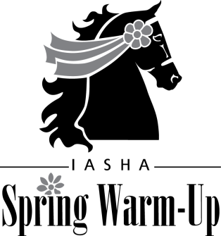

SPRING WARM-UP VENDORS
2023 RULES:

STATE and LOCAL PROTOCOLS REGARDING COVID -19 WILL BE IN EFFECT. This may include wearing masks and social distancing,

C Bar C Expo is a heated, enclosed, indoor facility. The vendor area is open to the show arena and located
adjacent to ringside tables and exhibitor bleachers between stabling and concession areas. Flooring in the
vendor area is concrete.

Tables and pipe & drape are not furnished – vendors should supply their own booth materials and exhibits. Single spaces can accommodate displays up to approximately 14’x14’. Please contact Melissa Cake, 317-965-2029 melm323@att.net, in advance if you
are interested in larger exhibit space. Please advise in advance of any special requirements.

Vendors will be assigned a location at the discretion of show management in accordance with the layout plan.

Vendors should be set up one hour prior to start of first session of the show on Friday, March 18. Because
vendor location is adjacent to the show ring, as a safety measure, no vendor will be allowed to set up or tear
down while the show is in session. Vendors may set up any time after 9am, Thursday, March 17 and
are requested to be open for business no later than 12:00pm, Friday March 18.

Vendors will be able to unload and load near the entrance to vendor area at the southwest corner of
Crossroads Arena but must park in exhibitor lot during show.

Show sessions are Friday 1:00pm, Friday 6:30pm, Saturday 9am, Saturday 1:30pm, Saturday 6:30pm, Sunday 9:00am, and
Sunday 1:30pm. A complete show schedule is available on line at www.indianasaddlebred.net.
Vendors may not tear down and leave the show facility until after last class on Sunday afternoon March 20.
All materials and products must be completely removed by 10 pm, Sunday, March

The C Bar C Expo requires all vendors to have current retail sales license and to collect Indiana State Sales
tax.

A list of area hotels can be found in the prize list on line at www.indianasaddlebred.net. Food is available on
the grounds and at several nearby restaurants.

Directions to C Bar C Expo: Take I-70 from Indianapolis or Terre Haute to Cloverdale/SR231 at Exit 41. Turn
south on SR231 to Stardust Road/925S. Turn right on Stardust Road/925S to facility on right (north) side of
road. C Bar C is approximately 1.5 mi from interchange. See www.cbarcexpo.com. C Bar C Expo phone number:
765-795-4768.

Please contact Melissa Cake, vendor chairperson, if you have any questions: 317-965-2029, melm323@att.net

